**Naomi Slipp**

**Bourke-White, Margaret (1904-1971)** 486 words

Margaret Bourke-White was an influential American photojournalist associated with *Life* Magazine. Bourke-White briefly studied at Columbia University under Photo-Secessionist Clarence White (1871-1925) before graduating from Cornell University in 1927. Opening a photography studio in Cleveland, Ohio, she specialized in industrial and commercial images that appealed to emerging modernist tastes. Widely published and highly lauded, Bourke-White achieved many firsts, including being the first woman to photograph combat zones. Her career transformed the male-dominated field of photojournalism. In 1927 Bourke-White photographed the dark interior of the Cleveland-based Otis Steel Company utilising magnesium flares to capture the industrial processes. The following year, Bourke-White documented the construction of the Chrysler Building in Manhattan. Both sets of photographs emphasise American industry and combine formal drama with tonal variation aligning Bourke-White with the “machine aesthetic” of modernist art. From 1929-35, Bourke-White photographed for Henry Luce’s *Fortune* magazine. For her first assignment, she took compelling images of the Swift hog processing plant. This was followed by three trips to the Soviet Union to document culture and industry in Stalin’s Soviet Union. Her 1931 photo-essay in *Fortune* was the first on life in the U.S.S.R. in a Western publication.

In 1936, Luce appointed Bourke-White as a photographer for *Life* magazine. Her first assignment was to photograph the New Deal construction of Fort Peck, the world’s largest earth-filled dam, in Montana. Her photo-essay appeared in the magazine’s first issue, while her cover image of the dam spillway towers became an iconic vision of American industrial progress in spite of economic depression. The same year, Bourke-White collaborated with author Erskine Caldwell on a book to document sharecroppers in the American South during the Dust Bowl. Her pictures of rural poverty and discrimination formed the core of *You Have Seen Their Faces* (1937) and mark her transition from commercial photographer to documentarian*.* During the Second World War Bourke-White photographed the rise of Nazi fascism and became the first female correspondent to photograph combat missions, earning the nickname ‘Maggie the Indestructible.’ While in the Soviet Union in 1941 she documented German air raids on Moscow. Following this, she flew missions with the U.S. Army Air Force in North Africa, Italy, and Germany and photographed the 1945 liberation of the Nazi concentration camp Buchenwald. These harrowing images were published in *Life*.

After the war Bourke-White documented South African mining and apartheid, Mahatma Gandhi and the Indian-Pakistani Partition, and the Korean War. Diagnosed with Parkinson’s disease, she retired from *Life* in 1957 to write her biography *Portrait of Myself* (1963). Bourke-White died in Stamford, CT in 1971.

**List of works**

Bourke-White, M. and Caldwell, E. (1937) *You Have Seen Their Faces*, New York: Viking Press.

Bourke-White, M. (1963) *Portrait of Myself*, New York: Simon and Schuster.

**References and further reading**

Goldberg, V. (1986) *Margaret Bourke-White: a biography,* New York: Harper & Row.

Phillips, S.B. (2003) *Margaret Bourke-White: The Photography of Design, 1927-1936,* New York: Phillips Collection in association with Rizzoli.

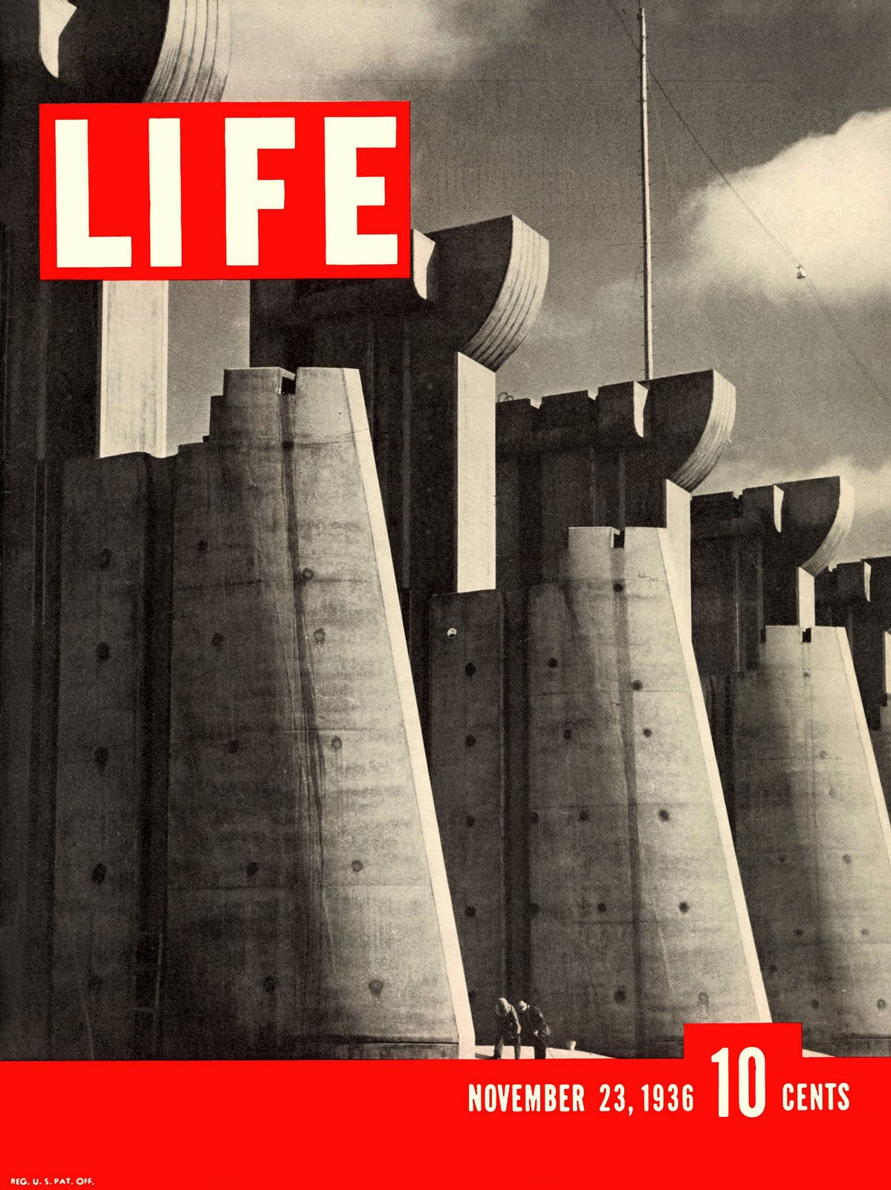

http://life.time.com/history/life-magazine-first-ever-cover-story-building-the-fort-peck-dam-1936/#1